### Probability of a Path in an HMM Problem

*Compute the probability of a hidden path in an HMM.*

**Input:** A hidden path *π* in an HMM (*Σ*, *States*, *Transition*, *Emission*).

**Output:** The probability of this path, Pr(*π*).

**Input Format.** The first line of the input contains the path *π* in the HMM The second line of the input is “--------” (a delimiter). The third line of the input is the list of states *States* (space-separated). The fourth line of the input is “--------” (a delimiter). The remaining lines are the transition matrix *Transition*, depicted as a tab-delimited |*States*| by |*States*| matrix. You may assume that transitions from the initial state occur with equal probability.

**Output Format.** The probability of this path, Pr(*π*), to at least 3 significant figures.

**Constraints.** 50 ≤ |*π*| ≤ 100; |*States*| = 10

**SAMPLE DATASET:**

Input:

ABABB

--------

A B

--------

A B

A 0.377 0.623

B 0.26 0.74

Output:

0. 0373380098

The figure below shows the HMM with two hidden states and its transition matrix. Although the (implicit) initial state is not shown, the transition probabilities from this state to A and B are equal to ½.

The following is the series of events that must have occurred to generate the hidden path ABABB:

* Start in state A: Since it is equally probable to start in any of the states, this event occurs with probability ½.
* A → B: Occurs with probability 0.623
* B → A: Occurs with probability 0.26
* A → B: Occurs with probability 0.623
* B → B: Occurs with probability 0.74

Thus, the probability of the path ABABB in the given HMM is the product of all of these probabilities, which is 0.0373380098.

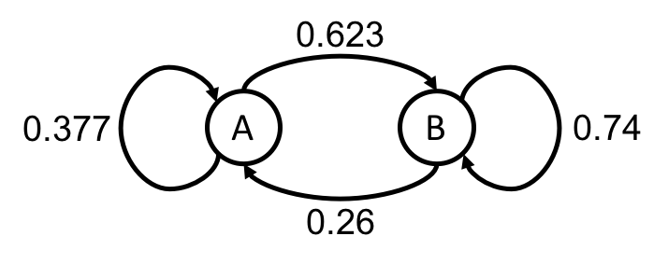

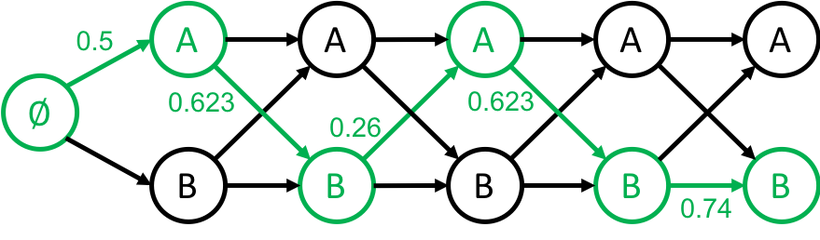

**TEST DATASET 1:**

Input:

A

--------

A B

--------

A B

A 0.425 0.575

B 0.228 0.772

Output:

0.5

This dataset makes sure that your code is using the correct transition probability from the initial state. In this problem we assume that transitions from the initial state occur with equal probability, so the probability of a path of length 1 will only depend on the total number of states. In this case your code should output 0.5 no matter what the values in the transition matrix are.

**TEST DATASET 2:**

Input:

AAB

--------

A B

--------

A B

A 1 0

B 0.5 0.5

Output:

0

This dataset makes sure that your code is correctly parsing the input path. The transition matrix given in this dataset does not allow for transitions from state A to state B. If your code misses the **last** state of the input path then it will output a result of 0.5 instead of the correct output of 0.

**TEST DATASET 3:**

Input:

ABB

--------

A B

--------

A B

A 1 0

B 0.5 0.5

Output:

0

This dataset makes sure that your code is correctly parsing the input path. The transition matrix given in this dataset does not allow for transitions from state A to state B. If your code misses the **first** state of the input path then it will output a result of 0.5 instead of the correct output of 0.

**TEST DATASET 4:**

Input:

BCAACAADD

--------

A B C D

--------

A B C D

A 0.1 0 0.3 0.6

B 0.5 0.4 0.1 0

C 0.3 0.3 0.3 0.1

D 0.2 0.5 0.1 0.2

Output:

8.10e-07

This dataset checks to make sure your output is to at least three significant figures. This is not the same as three digits past the decimal point. If your output is incorrect make sure that your code doesn’t round the final answer to three digits past the decimal point. Scientific notation using a lowercase e (as in the example output) is accepted. Do not output scientific notation in the style of 8.1*10-7 or 8.1x10-7.